**Activity diagrams for Clinic Scheduler Application**

1. Patient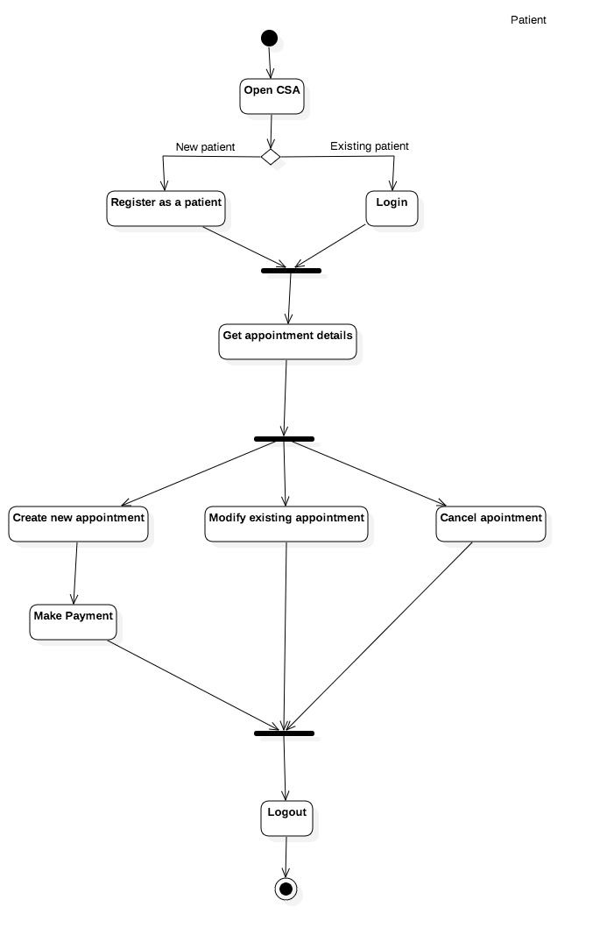
2. Clinic Receptionist

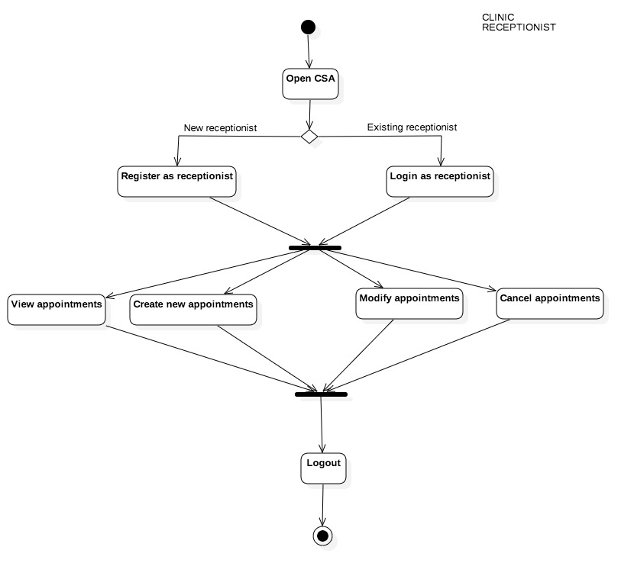

1. Doctor

